A Mixed Methods Look at Self-Directed Online Learning:
MOOCs, Open Education, and Beyond

Feng-Ru Sheu, National Sun Yat-Sen University, Kaohsiung City, Taiwan,

Mimi Miyoung Lee, University of Houston

Curtis J. Bonk, Indiana University

Xiaojing Kou, Indiana University

Abstract
There are an endless array of open educational resources (OER), open courseware (OCW), and massive open online courses (MOOCs) available for self-directed learning pursuits. This study explores the learning experiences, including the barriers, obstacles, motivations, and successes of directed online learners. Data collection included a 43-item survey of 2 large online learning communities: (1) 1,429 newsletter subscribers of the MIT OCW initiative, and (2) 159 participants enrolled in a MOOC hosted by Blackboard using CourseSites. This is a mixed methods design. The researchers qualitatively analyzed emerging themes from open-ended survey items as well as the descriptive statistics from the closed-ended items. The findings help capture informal and self-directed learning experiences through informal education channels, including OCW, OER, and MOOCs.
A Qualitative Look at Self-Directed Online Learning:
MOOCs, Open Education, and Beyond

We are in the midst of an incredible array of changes in both K-12 and higher education today that would have been unthinkable just a decade or two ago. People in remote parts of the world are learning from well-known professors at Princeton, Rice, Harvard, and MIT; typically, without a fee. Countless millions of individuals are engaged in self-directed, informal, and solitary learning experiences, while myriad others are highly engaging collaboratively learning with global peers who have signed up for the same course or experience.
As these learning experiments unfold, many aspects of the college experience are being called into question. There is debate about the value or even the need for a degree. According to Luke (2013), some corporate settings are bypassing traditional degrees as the sole determiner of ability and are beginning to find people who are self-determined to learn the corporate culture and work through nontraditional or informal learning on their own. Creativity and initiative are emphasized over following rules. Luke suggests that human resource departments seek job candidates who have a dual approach to development, combing degrees programs with self-education. Self-education may result in certificates, badges, or other credentials that are reflected on one’s resume, but does not have to. Hence, HR departments need to find new ways to ascertain the skills learned from informal learning pursuits.
In the midst of these changes, Friedman (2013) suggests that the revolution that he announced for the business world with his infamous book, “The World is Flat” (Friedman, 2005), has now migrated to higher education. In his upcoming book, Education 2.0: The Learningweb Revolution and the Transformation of the School,” Waks (in press) concurs with Friedman while offering a conceptual model to make sense of the possibilities. The factory model of education is being replaced by networked models. Waks points out that collaborative technologies, open access textbooks, e-books, learning repositories, social networking technology, Web conferencing, and open educational resources (OER) are enabling greater opportunities for learner self-determined or self-directed learning.
While a plethora of changes have rapidly coalesced, they have not transpired overnight. Detailed below are a few key trends and historical markers for this educational movement toward more free and open content.

The OpenCourseWare (OCW) Initiative
On April 4, 2001, Charles Vest, then president of MIT, made an historic announcement. He set a goal of having most of his university’s courses freely available on the Web in a decade. While some thought this to be a rather bold proclamation, by the early part of 2009, MIT had its entire curriculum of 1,800 courses online. MIT beat its original target by more than 3 years. Today, all of their courses remain available for self-directed learners around the globe to explore, download, use, and share. And they are continually updated, enhanced, and expanded upon. Anyone with an Internet connection can read, watch, or listen to these resources.
Vest had thought that the Council on Educational Technology that he had assigned to investigate online learning and opportunities outside classroom walls would come up with new revenue models. He did not envision that he would be giving away his contents on the Web. At the same time, he thought that the OpenCourseWare (OCW) project would be highly innovative and help advance education by widening access to it and inspiring other institutions of higher learning to also participate. As Vest noted,
This is about something bigger than MIT. I hope other universities will see us as educational leaders in this arena, and we very much hope that OpenCourseWare will draw other universities to do the same. We would be delighted if -- over time -- we have a world wide web of knowledge that raises the quality of learning -- and ultimately, the quality of life -- around the globe.
Vest viewed the OCW initiative as one that embraced ideas related to the openness of education as well as outreach to underserved populations as well as for retirees and others to learn new hobbies. Learners could draw upon these materials for self-study. At the same time, instructors could share contents through OCW types of projects on other campuses around the world. With more than 1 million visitors to the OCW website each month and another 500,000 for translated versions of the content, there is no doubt that Vest was correct in assuming that there was a population interested in such content.
Soon the OCW consortium was formed with over 250 other universities and associated organizations from Japan, Taiwan, China, Spain, Korea, Mexico, the Netherlands, and part of Africa as well as universities in the United States such as Tufts University, the University of Michigan, Johns Hopkins University, and the University of California, Irvine. Combined, these higher education institutions have made available more than 13,000 materials in 20 languages. MIT materials are available in English as well as in Spanish, French, Persian, Turkish, Korean, Thai, Portuguese, and Chinese.

Emergence of Open Educational Resources (OER)
Not only are thousands of these open courses available for self-directed study, but countless open portals are rich in educational content for self-discovery and informal learning as well as for more formal class activities. Free and open learning portals exist on most major figures in history including William Shakespeare, Jane Austin, Albert Einstein, Maria Montessori, and Winston Churchill. Some portals such as YouTube, TED, Academic Earth, and LinkTV exist are devoted to indexing shared online video (Bonk, 2011). Such portals are considered part of the open educational resource (OER) movement. As a new movement, there remains much to resolve when developing, sharing, or using OER; especially concerns about resource preservation, the sustainability of the content, intellectual property rights, content quality and enhancement, and measuring the impact of its use (Atkins, Brown, & Hammond, 2007; Downes, 2007).
OER is widespread not only in higher education settings, it has also emerged as a significant aspect of K-12 education. In fact, legislation is now pending for $500 million for grants to states and school districts for different aspects of educational technology, including online learning as well as the use of OER for improving efficiency and productivity (Stansbury, 2013). Along these same lines, the Obama administration is working on plans to provide public access to federally funded research (Rivard, 2013). In response, the Association of American Publishers has announced a novel project known as the Clearninghouse for the Open Research of the United States (CHORUS) that would free up peer-reviewed journal articles following a one year embargo (Rivard, 2013). Suffice to say, OER and open access to research is receiving much attention and funding the past several years. This raised awareness for OER is bound to lead to vast increases in informal as well as formal learners using such free and open materials.

The Rise of Massive Open Online Courses (MOOCs)
The evolution of OCW, OER, and online learning in general has led to the creation of massive open online courses (MOOCs). MOOCs illustrate the fact that we have entered an age of information abundance instead of information scarcity (Kop, Fournier, & Mak, 2011). Taking advantage of such resources, thousands, or even tens or hundreds of thousands of people around the world often enroll in a single MOOC experience such as one on social networking technology, sustainable health diets, introductory to chemistry, or artificial intelligence (Bowman, 2012).
Research from Rita Kop and her colleagues (Kop et al., 2011) documented that is it possible for a MOOC to provide more than traditional course information and assignments. MOOCs, in fact, can support the building of connections between those seeking to learn something and course facilitators as well as among the learners in a rich community of learners. When designed to harness information flows within networks of people, exciting and spontaneous learning can result. Individuals are sharing and adding to the resource pool, negotiating and communicating ideas, collaborate with others, and coaching and mentoring others. Such MOOCs illustrate ideas related to the theory of connectivism and have been branded as “cMOOCs” (Morrison, 2013). The first MOOC was offered by George Siemens of Athabasca University and Stephen Downes of the Canadian Research Council in 2008. It was a cMOOC.
It was not until three years later that MOOCs received national and international attention. It was then that a result of a series of MOOCs from Stanford each enrolled more than 100,000 participants (Beckett, 2011; Markoff, 2011). These were dubbed xMOOCs since they were taught in a similar fashion to campus-based lecture courses (Morrison, 2013). Since that time, MOOCs have drawn the attention of world leaders including Bill Gates (Young, 2012) for their ability to expand educational opportunities at a low cost.
With companies emerging such as Udacity, edX, Coursera, and NovoEd and a sea of partnerships with top tier higher education institutions, Laura Pappano of the New York Times declared 2012 to be “The Year of the MOOC” (Pappano, 2012). In her special review of MOOCs, thorny issues related to grading, feedback, quality, cheating, and learner background present problems for those offering MOOCs. In fact, most institutions have not yet offered a MOOC or even created a strategic plan for them (Allen & Seaman, 2013). However, research from Allen and Seaman indicates that a large percentage of university administrators are currently planning for a MOOC in the near future.
While MOOCs are typically free and open, there are an assortment of revenue models emerging. Among these are paying for optional assessments or certificates at the end of a MOOC or paying an entry or enrollment fee. Other business plans include free courses with paid advertising, selling student data (especially that related to high performing students), and having the first course in a degree program to be a free MOOC. ALISON, for instance, offers free online courses for basic workplace skills (e.g., financial and economic literacy, business and enterprise skills, introduction to banking, career planning, etc.) paid through advertisements (Bornstein, 2012). World Education University is using a similar advertisement-based model.
Among the key issues of MOOCs is participant retention and motivation. A recent studies of a MOOC at Duke University in the area of bioelectricity as well as a set of six MOOCs at the University of Edinburgh (e.g., critical thinking, introduction to philosophy, equine nutrition, AI planning, astrobiology, e-learning and digital cultures) indicate that the retention rate in a MOOC is often quite low (Catropa, 2013; MOOCs @ Edinburgh, 2013). In the Edinburgh study, participants signed up for various reasons including to learn about the subject matter, try online education, experience a MOOC, browse the course, obtain a certificate, improve career prospects, and become part of a learning community. More insights are needed about the motivational aspects of MOOCs as well as how to increase the percentage of those venturing beyond the first week of a MOOC experience and perhaps even completing it.

The Need for Self-directed Learning
As is clear from the brief review of the literature on OCW, OER, and MOOCs above, informal learning resources and tools are exploding online (Bonk, 2009). As a result, learning is becomes increasingly informal and self-directed or self-selected (Cross, 2007). This trend is pervasive across all age levels and occupations. For instance, some young people are skipping K-12 school settings and instead studying from OER (Al Haddad, 2011). Other youth who lack decent textbooks or where teachers are in short supply, such as young children in India, are learning from free videos provided by the Khan Academy (Chandrasekaran, 2012). At the same time, adolescents like 16 year old Timothy Donner are learning multiple languages through free online resources (Leland, 2012). As a teenage polyglot, Donner knows Yiddish, Russian, Persian, Swahili, Dutch, Hindi, German, and many other languages.
Online learning and free and open contents have also transformed life for adult learners. For instance, through OCW, OER, and now MOOCs, those stuck behind prison walls, injured and in a hospital bed, or unemployed and unable to pay for college tuition can learn to be more productive members of society. Others might be in transition from one career to another and find OER and OCW can arouse new interests and confidence (Iiyoshi & Kumar, 2008). Still others might be enrolling in open courses while in war zones in Iraq or Afghanistan (Kenning, 2012; Millard, 2011). If they are transferred, they can continue their education at their new base location.
The importance of self-directed learning (SDL) has been noted for decades (Deci & Ryan, 2008; Ryan & Deci, 2000). In recapping the literature on SDL, Abdullah (2001) noted that those who are self-directed learners tend to be highly curious, view problems as challenges, desire change, and are willing to try new things. They are also persistent, self-disciplined, goal oriented, independent, self-confident, and generally enjoy learning. As she puts it, they are “responsible owners and managers of their own learning.” Such individuals are highly attuned to the importance of making learning meaningful and relevant. Finally, and perhaps, most importantly, they also self-monitor, evaluate, and regulate one’s learning.
From this perspective, learners need opportunities to learn and a sense that they are free to learn when and where they feel the need (Reeve, 1996). According to Rogers (1983), learning should always be highly active and open, involve genuine tasks, and respect the background and ideas of all learners. Simply put, learning should be learner-driven and filled with opportunities for learners to make decision and take responsibility for their own learning. The more that learners can freely and openly explore learning experiences, the greater the chance that they will exhibit their creativity and participate in productive ways in the world at large (Rogers, 1969).
In effect, there is a need for learner choice and volition in the material that is selected and in the tasks in which they express their learning gains. Learner volition and inner will or purposeful striving toward some action or learning goal is at the crux or heart of self-directed learning pursuits. In recapping the literature on intrinsic motivation, Pink (2009) makes the claim that this internal drive system is focused on getting better at something that is personally meaningful or relevant; in essence, it matters.
In many ways, distance learning is the ideal platform for testing theories related to intrinsic and self-directed learning (SDL). For many of the pioneers of distance learning research, television, correspondence, and satellite learning were ideal learning formats for learners who were self-motivated (Wedemeyer, 1981). Building on decades of such learning formats, Garrison (1997) from the University of Calgary designed a comprehensive SDL model with three interacting dimensions; namely, (1) self-management, (2) self-monitoring, and (3) motivation. He pointed out that SDL is successful when learners can take control of the learning context to reach their personal learning objectives (Song & Hill, 2007). To attain to their goals, they must effectively manage the learning resources that are provided; often with little or no guidance. Of course, as learning online from OCW, OER, and MOOCs shifts control of the learning environment toward the learner, there are myriad problems, challenges, and opportunities for learners related to effective resource use. The barriers or challenges of many SDL environments include less immediate feedback and guidance, procrastination, and becoming overwhelmed by the resources made available.
Given these issues, it is not too surprising that the recent emergence of online learning and OER has reawakened interest in the field of self-directed learning (Hyland & Kranzow, 2011). Adults, in particular, are being pressured to keep their knowledge and skills up-to-date in order handle fast changing work requirements. As a result, lifelong learning and self-directed learning have risen in importance (Lin, 2008). However, there are relatively few studies of the experiences of self-directed online learners as they move through non-formal learning channels. Therefore, it is vital for researchers to explore the potential of more free and open learning materials and resources and what learners encounter as they explore them. In particular, there is a pressing need to better understand the obstacles and barriers to success in non-formal learning channels/environments by the people learning from open educational resources (OER), OpenCourseWare (OCW), and massively open online course (MOOCs).
The purpose of this study is to investigate self-directed online learning from OER, OCW, and MOOCs. As educators and instructional designers better understand possible obstacles of non-formal learning with OER and emerging learning technology, they can design and develop enhanced online learning contents and supports. In addition, documented life changes from OER can also serve as catalysts and benchmarks for others to try out such resources. The findings of the present study address many audiences including policy makers, learners, instructors, digital scholars, and researchers.

Research Methodology

Informal and Extreme Learning Website Analysis and Survey Construction
A list of over 300 informal and extreme learning Web sites was created by a team of researchers based on a thorough literature review as well as recommendations from soliciting experts recommendations, blog post reviews, and scanning other online resources. These Web resources included those related to language learning, adventure learning, social change/global education, virtual education, learning portals, and shared online video. A subteam of four individuals from the main team evaluated these sites using an eight-part coding scheme over a six month period (Jung, Kim, Wang, & Bonk, 2011). The Website evaluation criteria included aspects of the following: content richness, functionality of the technology, novelty (both technological and pedagogical), scalability, learning as well as life change potential, and extent of technology integration.
During the year evaluating hundreds of informal and extreme learning Websites, the researchers noted the diversity of informal learning experiences, range of skills or competencies emphasized, different delivery mechanisms and technologies utilized, motivational techniques employed, and potential barriers or obstacles to their use. Using this insight, a 43-item survey was designed using SurveyShare, a Web-based survey hosting service. The survey was intended to understand self-directed learning from such free and open online environments; including the collection of life changing stories. Items were refined, expanded, clarified, and, at times, deleted. Definitions of both informal learning as well as extreme learning were also crafted and inserted into the survey.
The close-ended portion of the survey inquired into many aspects of informal learning. Such areas included the goals one wished to accomplish through informal learning pursuits and activities (e.g., high scores, new friends, personal freedom, enhanced self-worth, etc.), reasons for exploring Web resources informally (e.g., curiosity, interest, professional growth, hobbies, goals for self-improvement, etc.), factors leading to success (e.g., choice, collaboration, identity, advice from others, sense of adventure, producing or creating something, etc.), what they would like to learn (e.g., a foreign language, artistic skills, environmental information, music skills, etc.), and typical barriers or obstacles faced when learning informally on the Web (e.g., lack of excitement, lack of time, technical problems, lack of quality resources, etc.). We also asked a question about what they would like to achieve (e.g., learn how to fix something, course credit, learn something that can be used to help others, etc.).
In addition to the initial 25 close-ended questions, respondents had the option to complete 15 open-ended questions that asked about their informal learning experience (See Appendix A for details on the “Open Ended Survey Questions”).
The survey was piloted internally and then externally. After such pilot testing, a survey was conducted of two different populations of self-directed learners.

Population

As detailed below, the research data was collected in August 2012 through a Web-based survey of two large online learning communities. Both communities were related to the use of OER and open course materials. The open-ended responses are the primary focus of this study. As a mixed methods study, these open-ended findings are supplemented by several quantitative results.

In terms of the first sample, a link to the 43-item survey was sent out to 3,800 participants of a massive open online course (MOOC) hosted by Blackboard using their CourseSites course management system. The MOOC, Instructional Ideas and Technology Tools for Online Success, was taught from late April to early June in 2012. There were 159 completed surveys from the Blackboard MOOC participants, including 49 who completed the optional open-ended items. The majority of the survey respondents were female (73%) and were from North America (81%). In addition, 72% were over 40 years old. Many respondents in this subject pool were college instructors who signed up for the MOOC as a means of enhancing their skills in teaching online. They found out about the MOOC through press releases from Blackboard as well as from an email sent to users of CourseSites.

In terms of the second population, the sample was derived from subscribers to the e-newsletter related to the popular MIT OpenCourseWare (OCW) initiative. At the time, the newsletter subscription list had more than 156,000 active subscribers, of which, some 41% were described as self-learners, 40% students, 15% educators, and 3% parents. About 26,700 people opened the email and 4,000 people clicked through to the survey. Some 1,429 people completed the survey, including 613 people who completed one or all of the survey items. About half of the respondents were age 40 or younger. The half that was over age 40 included 64 respondents over age 70; roughly 5 percent of the MIT OCW sample pool. In contrast to the Blackboard survey, most in the MIT sample were males (76%). Significantly fewer were from North America (618 people; 44 percent). Large numbers of respondents came from Asia (331 people; 23 percent), Europe (202 people; 14 percent), and South America (133 people; almost 10 percent). Among the top countries represented in the MIT OCW subscriber list were the United States, India, China, Brazil, Nigeria, Pakistan, Iran, Canada, the UK, Taiwan, Indonesia, Mexico, and Egypt.

The survey took around 15 to 20 minutes to complete. Our data analysis here focuses primarily on the purposes and goals and obstacles and challenges that these self-directed learners encountered while learning through non-formal educational channels including OCW and OER. For the purposes of this study, the qualitative data from relevant open-ended questions will be analyzed by a team of qualitative researchers with QSR NVivo for coding to enable the identification of themes and comparisons across such themes. Where appropriate, findings from the closed ended items supplemented the qualitative results. The next step in this research will be interviews and focus groups of some of the respondents identified in the qualitative analysis process.

Open-Ended Survey Questions
The open ended questions included those related to goals and aspirations using OER, OCW, and MOOCs. Participants were also asked about their most interesting and successful informal learning experiences and what they accomplished. In addition, they were asked how this activity was unusual, interesting, or different from ways in which they typically learn. Another open-ended item concerned suggestions that they might have for others wanting to learn informally with OER, OCW, and other Web resources and technologies.
Other open-ended items included those related to the informal learning influences and supports that they received. For instance, did they have any role models, mentors, tutors, or other aids? Also, how might friends and family members play a role in using OER? In terms of challenges or obstacles that they faced, what were the solutions that they came up with? The researchers also inquired into the different forms and types of technology that facilitated their learning when in informal and more extreme environments. Finally, the goals of future open education and associated technologies for their online success were explored. Key findings from the MIT OCW dataset will be briefly described below followed by some of the qualitative results for the Blackboard MOOC data.

Quantitative Findings: MIT OCW Data
The descriptive statistics for both studies have been collected. In the MIT sample, respondents typically used a laptop or desktop to access informal learning resources, though some used a smartphone or e-book reader. Home, school, universities, public libraries, and cafes were among the popular places for accessing informal learning resources and materials, though airports, buses, and trains were also commonly used.
When engaged in such efforts, more than 70% of these learners feel more in control and empowered over their learning as a result of their open education experiences. Interestingly, more than 6 in 10 felt better about themselves as learners after their open education experiences and nearly everyone indicated that they have indeed learned something new (See Figure 1). Over 40 percent felt better about themselves as human beings. While at the low end of Figure 1, about 1 in 5 respondents claimed to find a new job as a result of their informal learning. A similar percent received a certificate of some kind from one or more of their informal learning activities. Interesting, in the process, more than one-third changed their beliefs about learning. Another third found a new career interest. Clearly, informal online learning had a powerful effect on the MIT OCW participants.

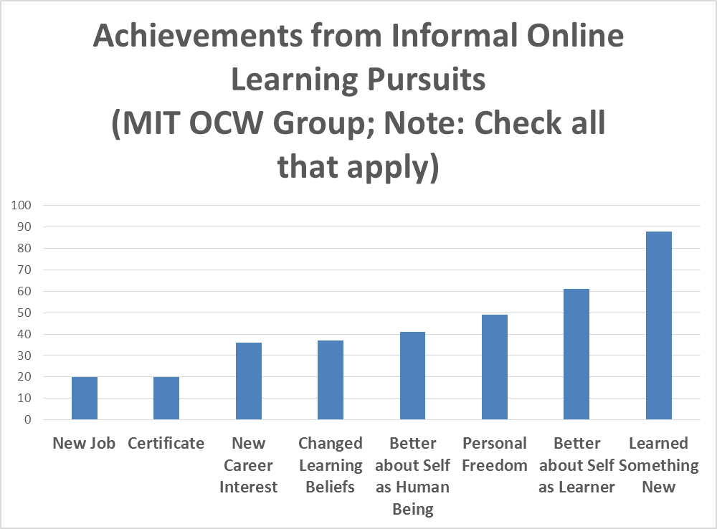
Figure 1. Achievements from informal learning pursuits.

As shown in Figure 2, intrinsic motivation trumped extrinsic. More specifically, curiosity, seeking information, self-improvement, and wanting to learn something were the key reasons to informally explore the Web to learn. In fact, nearly 70 percent had personal goals for self-improvement. More impressively, nearly 80% were simply interested in finding out about a particular topic (See Figure 2). More than half were doing so, at times, for professional development reasons.

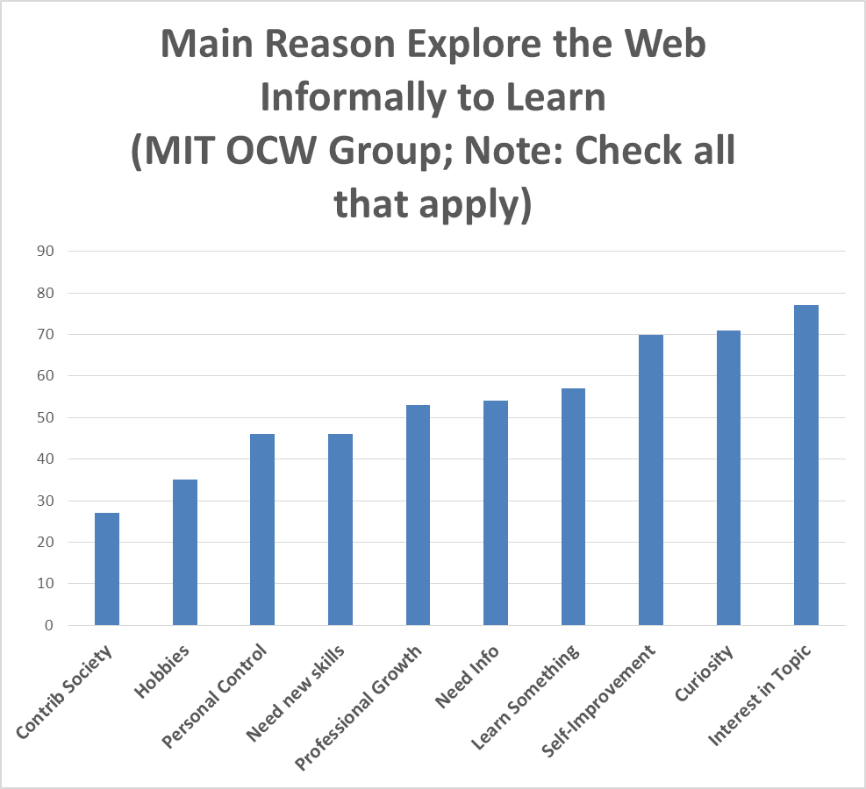
Figure 2. Main reasons to informally explore the Web to learn.

The researchers specifically asked about key factors that typically led to their online learning successes when engaging in informal online experiences (see Figure 3). Once again, freedom to learn was rated the highest (72%), followed by sense of resource abundance (47%), choice (44%), control over the activity or resource (41%), sense of fun (40%), and producing or creating something new (37%). Clearly, informal learners want the freedom to pick and choose what they want to learn. When the resource pool increases, so do the choices and opportunities for learner autonomy.

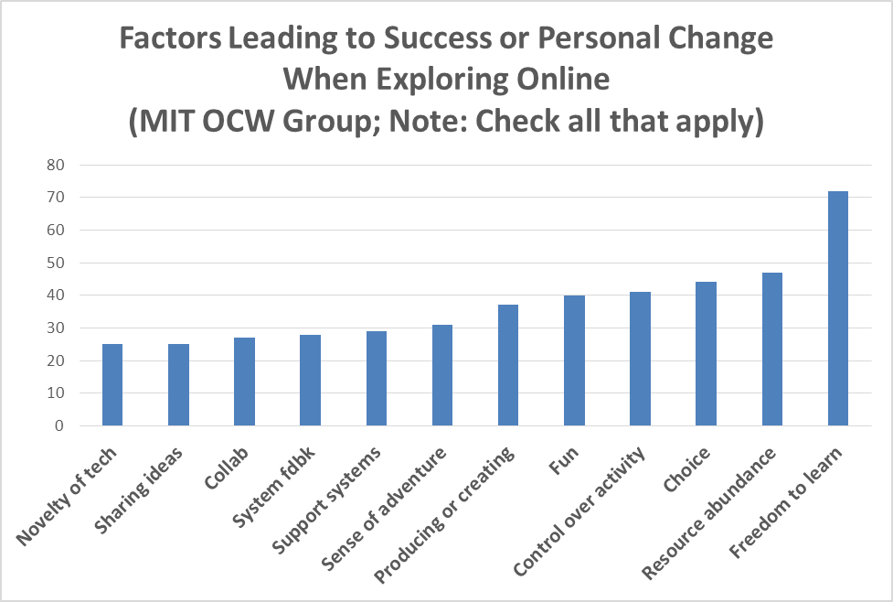
Figure 3. Factors leading to success or personal change what learning informally online.

Participants were asked what they would like to achieve from their informal learning endeavors (see Figure 5). While nearly 85% engaged in informal online learning for a new skill or competency, 57% were there to engage in a learning experience that would better their life. Some wanted to simple fix something at home (43 percent), whereas others had more grandiose goals of helping society (47 percent).
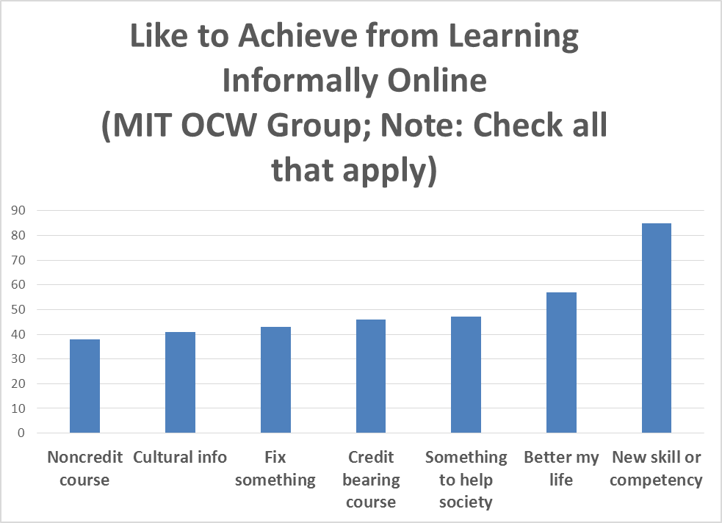
Figure 5. What would you like to achieve from informal learning online.

At the same time that many respondents noted their informal and self-directed learning successes, many others encountered significant obstacles. For instance, slightly under 20 percent noted a lack of access to the site or service or firewall barriers. Most significant was the lack of time to use (roughly 50 percent). Such time constraints are often noted by those enrolled in MOOCs and other time intensive online courses. Other issues might include the lack of support within one’s work environment for informal learning (17 percent), difficulty in using the site or service (23 percent), the lack of high quality open resources in a particular area (32 percent), and membership or technology fees (45 percent),
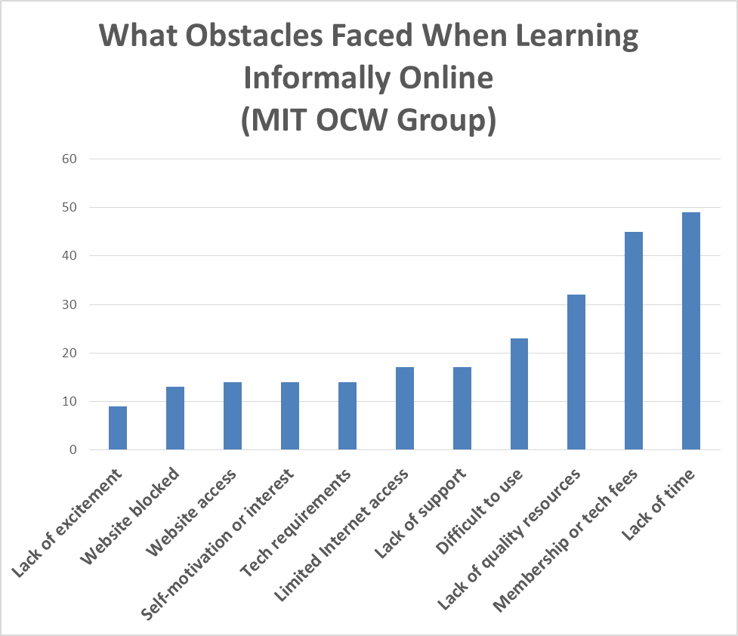
Figure 4. Obstacles and challenges faced when learning informally online.

Many of the above quantitative findings were elaborated on in the open-ended survey responses; some of which are recapped below. While the above findings stem from the MIT OCW survey, the open-ended survey results focus on responses from the Blackboard MOOC participants.

Qualitative Findings: MOOC Participants
When asked about their most interesting or successful informal learning experience, many of the MOOC participants focused on their most recent MOOC experience. Others discussed prior professional development experiences (e.g., learning a new screencasting software tool, finding resources for stories of indigenous populations of Australia for one’s class, etc.). Some detailed their hobbies and personal interests (e.g., learning Korean language from podcast shows while bike riding, learning a new recipe, finding information for sightseeing during a conference in New Orleans, watching TED talks on climate change or neuroscience, etc.). Others mentioned additional online courses or MOOCs that they had taken or were in the midst of. As a result, these findings do not relate strictly to MOOCs.
In terms of the purpose or goals from this activity, there were many motivators. Among our preliminary findings were five key motivators or goals: (1) wanted to improve their job prospects; (2) wanted to pursue personal interests or hobbies; (3) certification of some type; (4) information seeking; and (5) searching for ways to expand upon one’s formal learning.
In terms of information seeking, many participants see the Web as a means of self-reliance. This respondent noted that she and her husband were DIYers. “Today, we were trying to install a pool filter--we got instructions off You Tube. I also just bought a recumbent exercise bike--I looked at online reviews before making a choice. She then added, “Knowing that I did not need to ask an actual person for help was life changing. I am an introvert by nature, and I prefer to figure things on my own. Knowing that I can research informally on the Web is reassuring.”
There is also increased confidence and pride when one can be self-directed in learning, as this respondent noted, “I don't know if you consider this formal or informal but it has been something I have accomplished on my own. It has been empowering and rewarding to become a research detective online.”
Several traits or characteristics about those learning informally online emerged from the data. First, many felt a strong intrinsic motivation and prided themselves for being a self-directed learner. As part of this, they emphasized the aspect of informal learning that was most valuable; namely, “my own pleasure.” Such individuals valued their learning autonomy and considered it highly empowering. As one person stated, “I continue to research my interests for my own pleasure, especially on sites like Amazon for books and e-books, and have ongoing email alerts for journal content. I also use online sources for job hunting and professional networking.”
Another stated, “Knowing that I did not need to ask an actual person for help was life changing. I am an introvert by nature, and I prefer to figure out things on my own. Knowing that I can research informally on the Web is reassuring.” In effect, there is increased confidence and enhanced sense of self-efficacy as a learner.
Another trait of these informal learners was that they considered sharing to be an important part of the educational process. A third trait was their personal pride in creating or contributing something to the MOOC or informal learning resource that others could use. That is to be expected since, as noted in the literature review, self-directed learning often leads to exploration and creative outcomes (Lin, 2008; Waks, in press). However, it is a balancing act. As one person argued, when credentials like badges are added, they take away from the fun and enjoyment. It turns a playful pursuit of learning into a competition.
Just play around with ideas for alternatives to printed texts and don't be afraid to create your own, even if they're amateurish. Perhaps people who are experimenting can get together in groups: as writers people (including me) don't seek out readers enough and that will also apply to people experimenting with alternative modes. I think we need to de-emphasise formal assessment and accreditation and encourage our playful side to see what is possible. Too much informal learning wants to get itself 'badged' or validated too quickly and this means its losing its genuine amateur status.
In contrast, another respondent who successfully completed two workshops of Wiki Educator and learned many new skills about wikis found herself, “highly motivated to do all I could and learn as much as possible.” For her, the “certification scheme in the wiki workshop was also very motivating, and I achieved Wiki Apprentice 2 level so far.”
A fourth characteristic of these self-directed learning respondents was that they enjoyed meeting people with similar interests in an online community, though they would not necessarily enjoy FTF interaction with these same people.
So recap the qualitative findings, the preliminary findings can be summarized as the following: (1) Many people going online to learn are perpetual learners, including individuals who are looking to move up in their careers and others simply wanting to learn something new about a topic of interest; (2) Their obstacles include the typical ones of time, access, and understanding how to use the technologies; and (3) In terms of successes, these learners are amassing skills in physics, computer science, teaching, chemistry, business, law, and many other fields. They are learning through videos, discussions, documents, and a host of online resources.

Conclusions and Implications
It has been a little over a decade since Charles Vest’s courageous announcement about all courses from MIT being made available for free use online. The educational world has changed dramatically since that time. Not only are millions more people learning online in every educational sector—K-12, higher education, and corporate, military, and government training settings—but informal learning has simultaneously proliferated. The movement toward a more open educational system has shifted to highly massive endeavors that are prominent in the news such as MOOCs. The open educational world is discussed by educators, politicians, corporate executives, military leaders, and family members. As it rises in salience, most institutions of higher learning are deliberating on next steps. Some are struggling to come up with plans and solutions that incorporate open education.
It is vital to begin to understand the resources that informal learners find valuable to their changing learning needs. What are the purposes and goals that lead someone to use OER or to sign up for a MOOC? Also important is determining the obstacles and challenges in the way of informal learner success and satisfaction.
This study revealed some of those purposes and goals as well as the challenges and constraints. It seems clear that there is a wide gamut of reasons for informally learning from open educational contents including career change, personal interests, hobbies, professional development, and job requirements. Many find enjoyment in learning a new skill that they had not previously had a chance to enjoy. Some simply long for personal self-improvement. Still others want more control over their lives.

Future Directions
Given the findings, there are many directions for such research. First, direct interviews with participants should reveal specific motivational factors in accessing and using open educational contents. Do these motivational tendencies lean toward intrinsic aspects of motivation or more extrinsic ones? Inquiries into the benefits of informal learning pursuits should also be investigated. Do informal learners hope to receive some type of credential or badge from completion of a MOOC or passing a test related to their OCW explorations?
As a society that is shifting resources toward more free and open contents, there is a pressing need to understand how to foster self-directed learning from OER. First the characteristics of self-directed learners need to be better understood. Second, as these traits are uncovered, there might be training programs created as well as self-directed learning supports or scaffolds that might be embedded in OER or MOOCs at key moments in the learning process or available upon demand.
What those supports might look like is still unknown. What is certain, however, is that education is changing. Online and blended learning are disruptive forces that are shaking up traditional brick and mortar environments (Christensen, Horn, & Staker, 2013). Now add OER and MOOCs to the mix, and the waves of disruption seem to appear each day. New educational innovations will undoubtedly arise in the coming decade. Charles Vest ushered in this new century with his bold proclamation. He certainly will not be the last.
References
Abdullah, M. H. (2001, December). Self-directed learning, Eric Digest, EDO-CS-01-10. Retrieved from http://www.education.com/reference/article/Ref_Self_Directed/
Al Haddad, A. (2011, November 11). Too smart for school, too young for college. The National. Retrieved from http://www.thenational.ae/news/uae-news/too-smart-for-school-too-young-for-college
Allen, I. E., & Seaman, J. (2013). Changing course: Ten years of tracking online education in the United States. Babson Survey Research Group and Quahog Research Group, LLC. Retrieved from http://www.onlinelearningsurvey.com/reports/changingcourse.pdf
Atkins, D., Brown, J. S., & Hammond, A. (2007, February). A review of the open educational resources (OER) movement: Achievements, challenges, new opportunities. William and Flora Hewlett Foundation. (84 pages). Retrieved from http://www.hewlett.org/uploads/files/ReviewoftheOERMovement.pdf
Beckett, J. (2011, August 16). Free computer science courses, new teaching technology reinvent online education. The Stanford Report. Retrieved from http://news.stanford.edu/news/2011/august/online-computer-science-081611.html
Bonk, C. J. (2009). The world is open: How Web technology is revolutionizing education. San Francisco, CA: Jossey-Bass.
Bonk, C. J. (2011). YouTube anchors and enders: The use of shared online video content as a macrocontext for learning. Asia-Pacific Collaborative Education Journal, 7(1). Retrieved from http://www.acecjournal.org/2009/Journal_Data/Vol7No1/201103.pdf
Bornstein, D. (2012, July 11). Open education for a global economy. The New York Times. Retrieved from http://opinionator.blogs.nytimes.com/2012/07/11/open-education-for-a-global-economy/
Bowman, K. D. (2012, Summer). Winds of change: Is higher education experiencing a shift in delivery?, Public Purpose Magazine (from the American Association of State Colleges and Universities). Retrieved June 6, 2013, from http://www.aascu.org/WorkArea/DownloadAsset.aspx?id=5570
Catropa, D. (2013, February 24). Big (MOOC) data. Inside Higher Education. Retrieved from http://www.insidehighered.com/blogs/stratedgy/big-mooc-data
Chandrasekaran, A. (2012, October 15). Lacking teachers and textbooks, India’s schools turn to the Khan Academy to survive. The New York Times Blog. Retrieved from http://india.blogs.nytimes.com/2012/10/15/lacking-teachers-and-textbooks-indias-schools-turn-to-khan-academy-to-survive/
Christensen, C., Horn, M. B., & Staker, H. (2013, May). Is K-12 blended learning disruptive: An introduction of the theory of hybrids. The Clayton Christensen Institute for Disruptive Innovation. Retrieved from http://www.christenseninstitute.org/wp-content/uploads/2013/05/Is-K-12-Blended-Learning-Disruptive.pdf
Cross, J. (2007). Informal learning: Rediscovering the natural pathways that inspire innovation and performance. San Francisco, CA: Pfeiffer/Wiley.
Deci, E. L., & Ryan, R. M. (2008). Facilitating optimal motivation and psychological well-being across life’s domains. Canadian Psychology, 49, 14-23. Retrieved from http://www.psych.rochester.edu/SDT/documents/2000_DeciRyan_PIWhatWhy.pdf
Downes, S. (2007). Models for sustainable open educational resources. Interdisciplinary Journal of Knowledge and Learning Objects, 3. Retrieved from http://ijklo.org/Volume3/IJKLOv3p029-044Downes.pdf
Friedman, T. L. (2005). The world is flat: A brief history of the twenty-first century. New York, NY: Farrar, Straus and Giroux.
Friedman, T. (2013, January 26). Revolution hits the universities. The New York Times. Retrieved from http://www.nytimes.com/2013/01/27/opinion/sunday/friedman-revolution-hits-the-universities.html?_r=0
Garrison, D. R. (1997). Self-directed learning: Toward a comprehensive model. In Adult Education Quarterly, 48(1), 18-33.
Hyland, N., & Kranzow, J. (2012). Faculty and student views of using digital tools to enhance self-directed learning and critical thinking. International Journal of Self-Directed Learning, 8(2), 11-27. Retrieved from http://sdlglobal.com/IJSDL/IJSDL8.2.pdf
Iiyoshi, T., & Kumar, M. S. V. (2008). Opening up education: The collective advancement of education through open technology, open content, and open knowledge. Cambridge, MA: MIT Press. Retrieved from http://mitpress.mit.edu/catalog/item/default.asp?ttype=2&tid=11309&mode=toc
Jung, E., Kim, M., Wang, Y., & Bonk, C. J. (2011, October). What technology tools promote such extreme learning? Analysis of technologies used in extreme learning Websites. Proceedings of the E-Learn Conference 2011—World Conference on E-Learning in Corporate, Government, Healthcare, and Higher Education. Honolulu, Hawaii (pp. 2581-2587), Chesapeake, VA: AACE.
Kenning, C. (2012). For Knox soldiers earn deployed degrees. Courier-Journal. Retrieved from http://www.courier-journal.com/article/20120605/NEWS01/306050003/Fort-Knox-soldiers-earn-deployed-degrees
Kop, R., Fournier, H., & Mak, J. S. F. (2011, November). A pedagogy of abundance or a pedagogy to support human beings? Participant support on massive open online courses. International Review of Research on Open and Distance Learning (IRRODL), 12(7). Retrieved from http://www.irrodl.org/index.php/irrodl/article/view/1041/2025
Leland, J. (2012, March 9). Adventures of the teenage polyglot. The New York Times. Retrieved from http://www.nytimes.com/2012/03/11/nyregion/a-teenage-master-of-languages-finds-online-fellowship.html?pagewanted=all
Lin, L. (2008). An online learning model to facilitate learners’ rights to education. Journal of Asynchronous Learning Networks, 12(1), 127-143. Retrieved from http://www.distanceandaccesstoeducation.org/contents/JALN_v12n1_Lin.pdf
Luke, M. (2013, February 13). Formal versus self-education: Which is better? Chief Learning Officer. Retrieved from http://clomedia.com/articles/view/formal-v-self-education-which-is-better
Markoff, J. (2011, August 15). Virtual and artificial, but 58,000 want a course. The New York Times. Retrieved from http://www.nytimes.com/2011/08/16/science/16stanford.html?_r=0
Millard, E. (2011, March). Going the distance. University Business. pp. 34-36, 38-39. Retrieved from http://www.universitybusiness.com/article/going-distance
MIT News. (2001, April 4). MIT to make nearly all course materials available free on the World Wide Web. MIT Press Release. Retrieved from http://web.mit.edu/newsoffice/2001/ocw.html
MOOC @ Edinburgh 2013 – Report #1 (2013). MOOC @ Edinburgh 2013 – Report #1. University of Edinburgh, Edinburgh, Scotland. Retrieved from http://www.era.lib.ed.ac.uk/bitstream/1842/6683/1/Edinburgh%20MOOCs%20Report%202013%20%231.pdf
Morrison, D. (2013, April 22). The ultimate student guide to xMOOCs and CMOOCs. MOOC News and Reviews. Retrieved from http://moocnewsandreviews.com/ultimate-guide-to-xmoocs-and-cmoocso/
Pappano, L. (2012, November 2). The year of the MOOC. The New York Times. Retrieved from http://www.nytimes.com/2012/11/04/education/edlife/massive-open-online-courses-are-multiplying-at-a-rapid-pace.html?pagewanted=all
Pink, D. H. (2009). Drive: The surprising truth about what motivates us. New York: Riverhead Books.
Reeve, J. (1996). Motivating others: Nurturing inner motivational resources. Allyn and Bacon: Boston.
Rivard, R. (2013, June 5). How to provide open access. Inside Higher Education. Retrieved from http://www.insidehighered.com/news/2013/06/05/publishers-universities-both-prep-open-access-plans
Rogers, C. R. (1969). Freedom to learn: A view of what education might become. Columbus, OH: Charles Merrill.
Rogers, C. R. (1983). Freedom to learn for the 80s. Columbus, OH: Charles E. Merrill Publishing Company.
Ryan, R. M., & Deci, E. L. (2000). Self-determination theory and the facilitation of intrinsic motivation, social development, and well-being. American Psychologist, 55, 68-78. Retrieved from http://www.psych.rochester.edu/SDT/documents/2006_RyanDeci_Self-RegulationProblemofHumanAutonomy.pdf
Song, L., & Hill, J. (2007). A conceptual model for understanding self-directed learning in online environments. Journal of Interactive Online Learning, 6(1), 27-42. Retrieved from http://www.ncolr.org/jiol/issues/pdf/6.1.3.pdf
Stansbury, M. (2013, February 15). New ed-tech bill supports digital learning, Common Core. eSchool News. Retrieved from http://www.eschoolnews.com/2013/02/15/new-ed-tech-bill-supports-digital-learning-common-core/print/
Vest, C. (2001, April 4). MIT to make nearly all course materials available free on the World Wide Web. MIT News. Retrieved June 6, 2013, from http://web.mit.edu/newsoffice/2001/ocw.html
Waks, L. J. (in press). Education 2.0: The learningweb revolution and the transformation of the school. Builder, CO: Paradigm Publishers.
Wedemeyer, C. A. (1981). Learning at the back door: Reflections on nontraditional learning in the lifespan. Madison, WI: University of Wisconsin Press. Reissued: September 2010.
Young, J. R. (2012, June 25). A conversation with Bill Gates about the future of higher education. The Chronicle of Higher Education. Retrieved from http://chronicle.com/article/A-Conversation-With-Bill-Gates/132591/

Appendix A
OPEN ENDED SURVEY ITEMS
Open Ended Items (optional)
(28) Some people learn a lot from exploring Web resources or information on their own. Can you describe your most interesting or successful informal learning experience? What did you accomplish? Please provide as many details of your story as you can remember.
(29) In what ways was this informal learning activity unusual, interesting, or different compared to how you have learned in the past or compared to others?
(30) Why did you want to do this learning activity or task? What was your purpose or goals? Please describe what captured your interest.
(31) Has your life changed in a small or big way as a result of this informal learning activity or experience? If so, how?
(32) What was the key moment when learning informally with technology where you felt a personal change? If so, please describe that moment, as best you can. For instance, were there certain things you recall happening that led to this key moment?
(33) Did any of this influence your personal, school, or social life? If so, how or in what ways?
(34) Did you face any obstacles or challenges during this time when learning informally with technology? If so, how did you overcome them?
(35) What did you think about during this event or experience? Did you share your thoughts about this informal learning activity with anyone else? Please explain.
(36) Who or what influenced you to learn informally online or use a certain technology or online resource? Did you have any role models or mentors? Did anyone help you? If so, how?
(37) Did others help or support you to learn this way? For example, were there any friends, family members, or organizations that might have helped you?
(38) What role did technology play (if any) in this key moment? Stated another way, how did technology help your informal learning experience?
(39) Were there any cool, extremely different, or unusual uses of technology that helped you learn or succeed?
(40) Were there any particular technologies that you wish you had that might have helped improve your overall experience?
(41) Imagine someone trying to accomplish the same thing 10 years in the future. Can you think of what technologies or other supports they might use to accomplish a similar task? What technologies might you use in the future?
(42) How might others try to do what you are doing? Do you have any suggestions for others who want to learn on their own or informally with Web technology or resources?

