Preconference COP: Wisconsin Distance Teaching and Learning Conference
Title: Open All the Way: MOOCs, OER, and Open Education
Date: August 8, 2012
Time: 1:30-4:30
Location: Madison, Wisconsin

Ray Schroeder, Associate Vice Chancellor for Academic for Online Learning, University of Illinois at Springfield
rschr1@uis.edu

Curt Bonk, Professor, School of Education, IST Department, Indiana University
cjbonk@indiana.edu

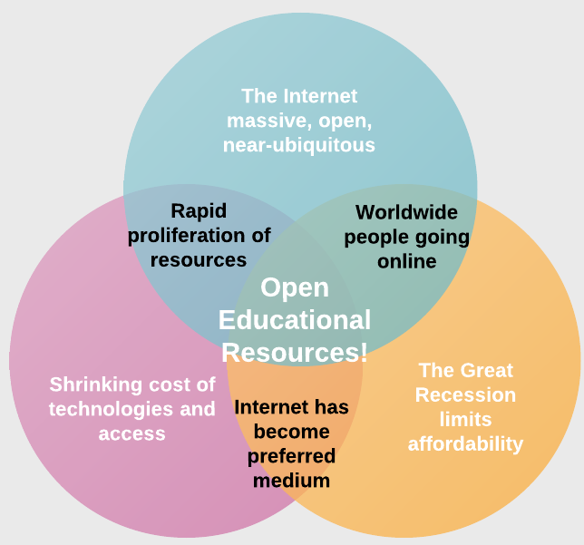

(c) Ray Schroeder 2011.

Learning Objectives for the session are:
- Understand the nature and variety of MOOCs - as well as other open online resources (OCW, OER, etc.).
- Be able to discuss the variety of delivery options for MOOCs from the organized options such as Udacity and Coursera to the individual offerings.
- Envision a variety of ways in which MOOCs may come to meet educational needs in society.
- Be able to discuss assessment / credit issues and options in MOOCs.
- Conceptualize a MOOC which you would like to coordinate, deliver or support at your institution.
- Contribute to an on-going, continuing community of practice in open online/MOOCs that will be of value to all participants.

Possible MOOC Questions:
  - What are the 3 things you want to take away from this COP session?
  - What excites you most about MOOCs?
  - What concerns you most about MOOCs?
  - What changes in education do you perceive that are coming soon?
  - Will degrees in higher education cease to exist? Change? No changes?
  - How will assessments change?

Tentative Agenda:
- Ice Breaker (15 minutes)
What is a MOOC? by Dave Cormier: http://www.youtube.com/watch?v=eW3gMGqcZQc
- Participants: Record 3 new ideas and 3 questions
- Sit and share: find person to right or left and share with neighbor (99 seconds)
- Stand and find one person do not know and share (99 seconds)
- Stand and share Part 2: find one person do not know and share (99 seconds).
- Ask questions of Curt and Ray…
- Laying Out the Questions: Disruption, New Forms of Assessment (e.g., Badges), and Transferability Ray (with some help from Curt) (15 minutes)
- Background info (OER, higher ed data, MOOCs)…Ray (15 minutes)
- Participants: Summarize and share 1 data point from Ray that will impact them and why. (10 minutes)
- Overview of 2011-2012 MOOC news, OER, and related trends…Curt (15 minutes)
- Participants: What are 2-3 items in news that surprised you and why? (10 minutes)
- MOOC experiences and top 10-20 takeaways—Ray (10 minutes)
- Participants: 1-2 audience members share a MOOC, OER, or OCW experience (5 minutes)
- Break
- MOOC experiences and top 10-20 takeaways—Curt (10 minutes)
- Participants: What is 1 course that you would like to take in a MOOC? (5 minutes)
- Video #2 (15 minutes)
Daphne Koller: What we're learning from online education, June 2012, Posted August 2, 2012;
TED: http://www.ted.com/talks/daphne_koller_what_we_re_learning_from_online_education.html YouTube: http://www.youtube.com/watch?v=U6FvJ6jMGHU
  - Coursera Courses: 3:30-7:52 minute mark: http://www.tubechop.com/watch/465282
  - Study Group Community: 12:04-16:00 minute mark: http://www.tubechop.com/watch/465285
  - Audience shares top 3 things from these two videoclips.
- Participants: Everyone team and start design for a MOOC or a MOOC plan (15 minutes)
  - Considerations
  - Pedagogies
  - Infrastructure
  - Constraints
  - Marketing
- Participants Teams Present plans (15 minutes)
- MOOC business models—Curt and Ray present and debate possible models (10 minutes)
  - Small teams brainstorm business plans and strategic plans (15 minutes).
- Revisiting the Questions: Disruption, New Forms of Assessment (e.g., Badges), and Transferability (5 minutes)

Ray Schroeder’s Notes and Info:
MOOC Info for Madison COP: https://sites.google.com/site/moocmaking/
Bio and Notable Activities: http://tinyurl.com/rayschroeder
Homepage: http://sites.google.com/site/rayschroeder
CV: http://dl.dropbox.com/u/4016482/Curriculum%20Vitae.pdf

Curt Bonk’s Notes and Info:
PDF of MOOC Slides for Madison COP: http://www.trainingshare.com/pdfs/MOOC_News.pdf
Download the Original MOOC Slides: http://mbf.cc/g3tny
Bonk Talk Archives: http://www.trainingshare.com/workshop.php#Madison2012
Homepage: http://mypage.iu.edu/~cjbonk/

